**COLLEGE: 8151-** Dhanalakshmi Srinivasan Institute of Technology Samayapuram Trichy

**DEPARTMENT:** B.E. Electronics and Communication Engineering

**NAAN MUDHALVAN COURSE:** Digital Marketing

**TEAMID:** NM2023TMID01814

**TEAM MEMBERS**: V.PRITHINGA

**NMID** : D1F12A6C636CEFD85AC4A56D20B489C0

**PROJECT DESCRIPTION**

A restaurant is a business that prepares and serves food and drinks to customers. It typically offers a variety of menu options, ranging from appetizers and entrees to desserts and beverages. Restaurants often specialize in particular cuisines, such as Italian, Chinese, or American, and can cater to various dining preferences, including vegetarian, vegan, and gluten-free diets. The ambiance and service of a restaurant contribute to the overall dining experience, making it a popular destination for social gatherings, special occasions, or everyday meals. In the digital marketing realm, restaurants utilize various online platforms and strategies to promote their services, attract customers, and enhance their overall visibility and reputation.

**BRAND NAME:** Mr.Fries

**CATEGORY:** Restaurant

**TARGET AUDIENCE:** All (Men, Women and Children)

**BRAND DESCRIPTION**

Mr. Fries is not just a restaurant; it's an experience that tantalizes the taste buds and brings joy to every palate. With a commitment to culinary excellence and a passion for innovation, Mr. Fries curates a delightful fusion of flavors, where every dish is crafted with care and creativity. Our mission is to create a welcoming ambiance where friends and families can relish not just the food, but also the warmth and camaraderie that comes with every visit. With a focus on quality ingredients and a menu designed to cater to diverse tastes, Mr. Fries aims to redefine the art of indulgence, one bite at a time.

**PROJECT DOCUMENTATION**

**E-MAIL ID:**  mrfriesrestaurant@gmail.com

**PASSWORD:** jppg@2023

**LOGO THEME:** Black and White

**DEMO VIDEO LINK:** [**https://youtu.be/0ojgz6tDfnQ?si=-tX3KzbL5Nu98jD9**](https://youtu.be/0ojgz6tDfnQ?si=-tX3KzbL5Nu98jD9)

**LOGO DESIGN**

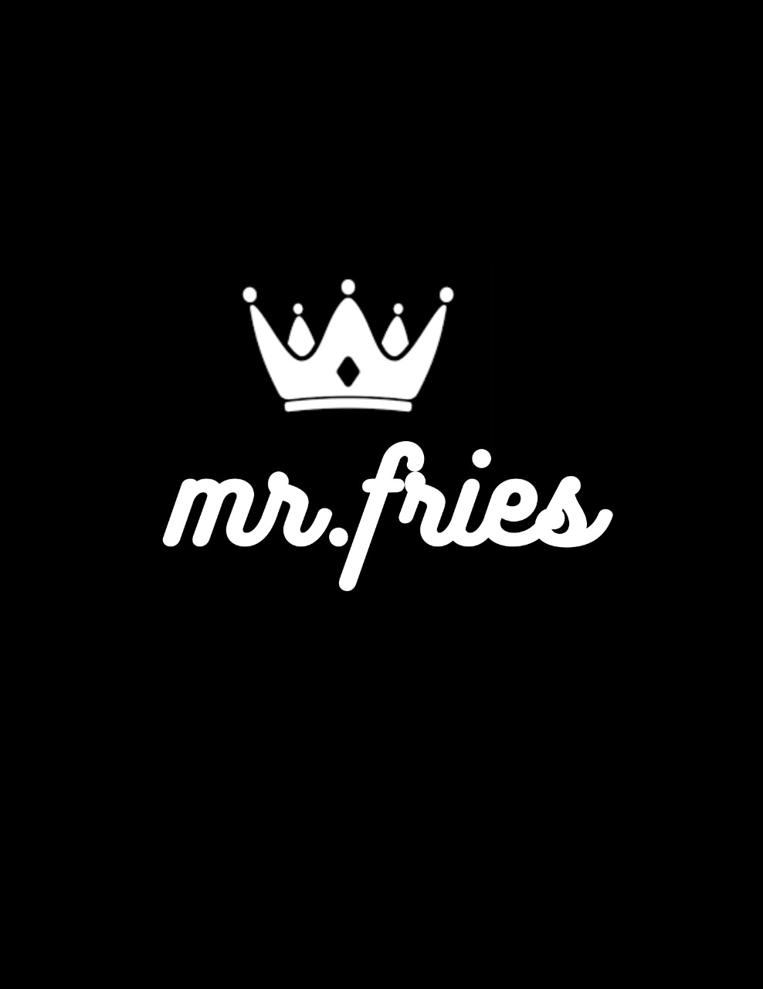

**E-MAIL CREATION**

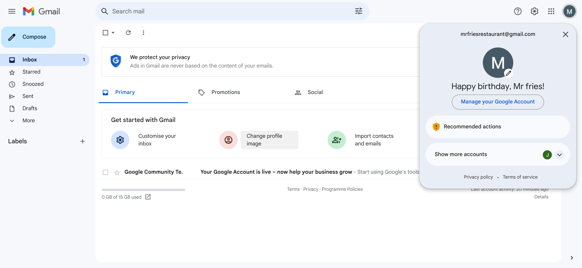

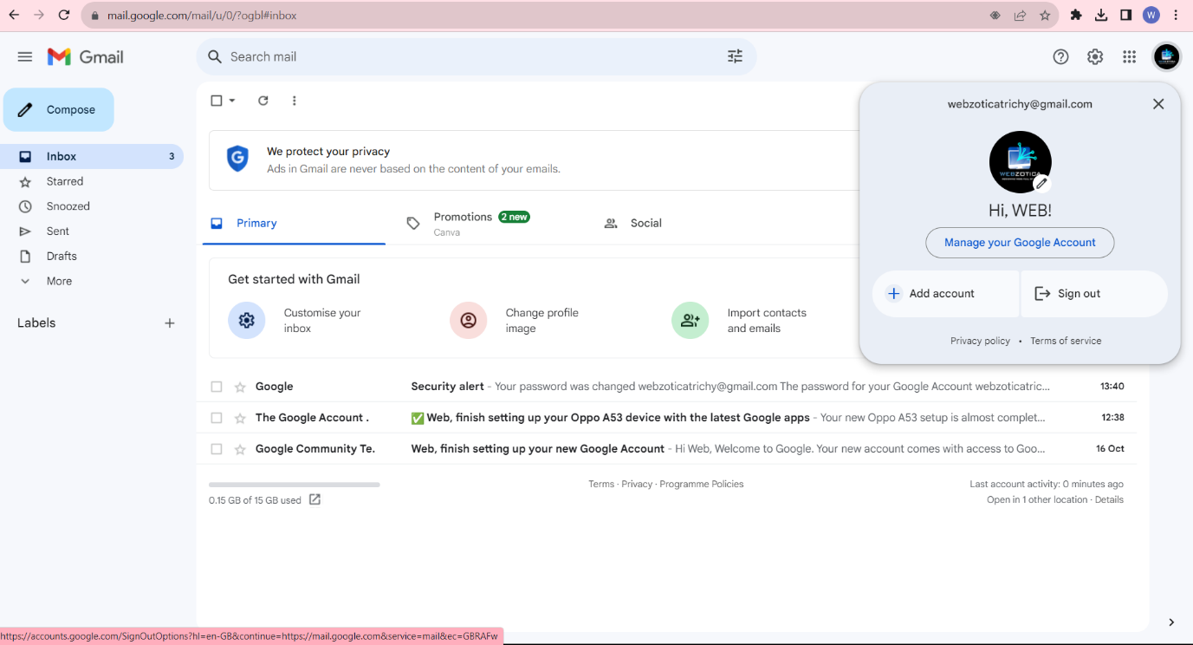**progress screenshot:**

